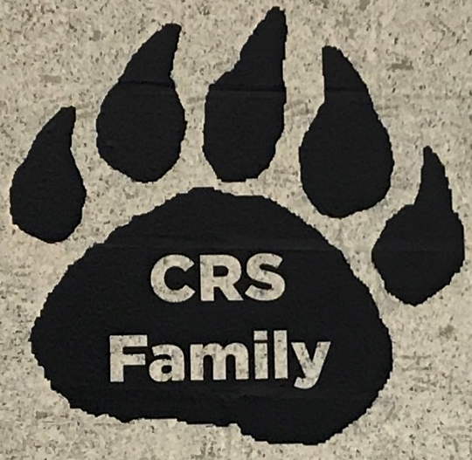
CRS PTA School Spirit Fundraiser

Who wants to be the first family to have their name prominently displayed in school?

We have a special offer this year for our CRS families!

For $100 you may choose to have your family’s name stamped on a 23” X 23” vinyl paw print that will hang in CRS for years to come. The paw print will say
“The (your name here) Family”.

Please complete the information you would like to have written on your paw print below:

Family Name ___________________________________________

Phone Number__________________________________________

Please send in cash or a check made out to CRS PTA and return to school marked “Paw Print”

Questions? Please email ginafsmedley@gmail.com

Thank you for supporting your CRS PTA!!

CG

