CRS PTA MEMBERSHIP FORM | Join Today!
We all are the CRS PTA - Parents, guardians, teachers and staff. Your annual membership helps support all that we do. Each year, CRS PTA donates extensively to provide classroom supplies, books, media and technology to our school. We plan and fund all school assemblies, a full-day Education Day, book fairs, amazing family events and so much more! As a PTA member, we encourage you to lend your talents to benefit our children: serve on committees, attend PTA meetings, vote on decisions and share your ideas. We need you!
Please send in your completed form with payment (checks payable to CRS PTA) by
Friday, September 25th.
Return to Colonial Road School in an envelope marked “PTA MEMBERSHIP”
Questions? Please contact Gina Smedley, PTA Membership Coordinator, at ginafsmedley@gmail.comBERSHIP 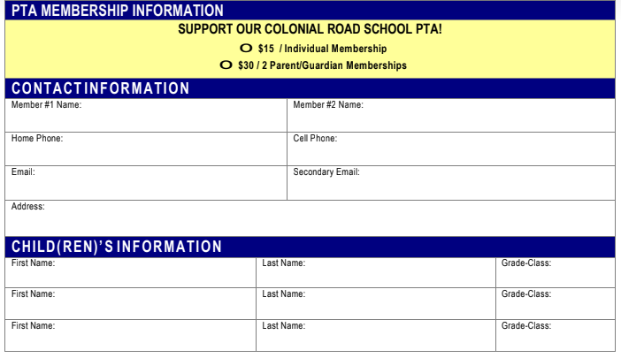I*Please note the NJPTA requires us to register all individual members and their email address(es) with the PT Avenue portal. Your PTA Membership card will be emailed to you directly from PT Avenue. **CRS PTA will be publishing a list of all PTA members to share within our school. Please check here if you DO NOT want your name included ____.
□ I may be interested in volunteering for a PTA committee. I would like to learn more!
□ I’d love to help out!! I can be your: dance party DJ __ graphic designer ___ web master ___
OR please share your talent with us! _______________________________________
Thank you for your support as we strive to reach our goal of 100% participation from Parents and Teachers Alike!

